Evaluating the Impact of Artificial Intelligence on the Job Market

Parmar Parth Jitendrakumar

Dissertation submitted to the International Business School for the partial fulfilment of the requirement for the degree of MASTER OF SCIENCE IN IT FOR BUSINESS DATA ANALYTICS.

December 2025

DECLARATION

This dissertation is a product of my own work and is the result of nothing done in collaboration. I consent to International Business School’s free use including/excluding online reproduction, including/excluding electronically, and including/excluding adaptation for teaching and education activities of any whole or part item of this dissertation.

Parmar Parth Jitendrakumar

Word length: 12650

ACKNOWLEDGEMENT
I​‍​‌‍​‍‌​‍​‌‍​‍‌ am really fortunate and thank my faculty supervisor a lot for their continuous support, valuable feedback, and academic assistance to the business data analytics project. It was, in fact, their idea and their insistence which made me have the breakthrough to content, the layout, and the analytical depth of the research.
I also want to thank the Institute of Business Studies (IBS) for giving the academic framework, the study materials, and the learning-by-doing activities that were very helpful in carrying out a data-driven project like this. The Business Data Analytics curriculum has been very instrumental to me in terms of technical and analytical skills, particularly in the use of Python-based analytics and machine learning methods for solving real-world business problems.
I would like to thank my parents for their never-ending encouragement, patience, and support during my academic journey that has made it possible for me to complete this project ​‍​‌‍​‍‌​‍​‌‍​‍‌successfully.

EXECUTIVE SUMMARY
The​‍​‌‍​‍‌​‍​‌‍​‍‌ AI revolution is altering global labor markets on a huge scale. Apart from changing job roles, it is also modifying the skills required and the wages paid. In order to maintain their position in the market, companies are making investments in AI technology. As a result, they are becoming more efficient, robots are taking over the dull tasks, and AI is facilitating decision-making/ processes/ execution/ operations, etc.Though, this development has an abundance of opportunities in the job market, it is still a risk for the so-called "workforce transition" (displacement, reskilling, wage inequalities, etc.) They are very keen on employing a business data analytics approach to study and foresee the influence of AI on employment patterns between 2024 and 2030.
This research paper refers to a simulated and structured dataset "AI Impact on Job Market (2024-2030)" that comprises attributes at job and industry levels such as automation probability, skill categories, skill demand levels, salaries (current and projected), and employment trends to provide information for the study.The quantitative research design was implemented through exploratory data analysis (EDA), statistical methods, clustering, and predictive modeling with Python. ​‍​‌‍​‍‌​‍​‌‍​‍‌.
From the Exploratory Data Analysis view point, Automation exposures vary significantly both across different industries and within job roles. Sectors like manufacturing, logistics, transportation are at higher risk of automation, while healthcare and education are relatively safe due to their dependence on human judgment and soft skills. The Roles that require digital, analytical, and AI-related skills, also pay higher and have stronger pipeline of growth potentials, thereby emphasizing that in the AI-driven labor market skills-based differentiation is crucial.
Cluster analysis has segmented the positions according to different risk factors, such as risk of automation, skill demand, and salary features. Besides the identification of the group of job categories that are most at risk of being automated, the undertaken research providing an accurate view of the groups resiliants too. Along with the regression-based models, the predictive modeling methodologies, including the proxy variables, suggests that the probability of automation has a negative influence reflected in the perceiving of a slowdown in salary increases, whereas a high advanced skill demand is a predictor of wage growth.
The data obtained in the study are in line with the purpose of the project and support the formation of the presented research hypotheses. Such results serve as a source of operational knowledge for organizations, legislators, and labor planning specialists by pinpointing the zones where the workforce needs reskilling, setting the stage for strategic hiring, and the reorganization of pay schedule. This demonstration of the power data analytics and machine learning bear in the era of AI to aid workforce planning and facilitate the execution of strategic decisions is ​‍​‌‍​‍‌​‍​‌‍​‍‌undeniable.
Table of Contents
DECLARATION ii
ACKNOWLEDGEMENT iii
EXECUTIVE SUMMARY iv
CHAPTER 1: INTRODUCTION 1
1.1 Background and Context of the Project 1
1.2 Business and Technical Significance of the Chosen Problem 1
1.3 Clear Problem Statement and Research Objectives of the Project 2
1.4 Research Hypotheses 3
1.5 Scope of the Study and Expected Contributions 3
CHAPTER 2: LITERATURE REVIEW 4
2.1 Overview of Relevant Theories, Frameworks, and Prior Studies 4
2.2 Discussion of Advanced Data Analytics Techniques Relevant to the Problem 5
2.3 Identification of Gaps in the Literature Addressed by This Project 6
CHAPTER 3: RESEARCH METHODOLOGY 8
3.1​‍​‌‍​‍‌​‍​‌‍​‍‌ Research Design and Approach 8
3.2 Data Source and Dataset Description. 8
3.2.1 Data Source 8
3.2.2​‍​‌‍​‍‌​‍​‌‍​‍‌ Dataset Structure 9
3.3​‍​‌‍​‍‌​‍​‌‍​‍‌ Data Pre-processing and Preparation 9
3.3.1 Data Cleaning 10
3.3.2 Data Transformation 11
3.4 Analytical Framework and Techniques 12
3.5 Model Validation and Reliability 13
3.6 Ethical Considerations and Limitations 13
Chapter 4: Exploratory Data Analysis (EDA) 14
4.1 Descriptive Statistical Analysis 14
4.2 Industry-Wise Automation Analysis 15
EDA: Automation risk by industry 16
4.3​‍​‌‍​‍‌​‍​‌‍​‍‌ Skill Demand and Job Role Analysis 17
EDA: Salary vs Automation Risk 17
4.4 Correlation Analysis and Regression Analysis 18
Clustering and Predictive Modelling 21
4.6 Summary of EDA Findings and Link to Further Analysis 26
CHAPTER 5: IMPLEMENTATION OF ALGORITHMS AND MODELS WITH RESULTS AND ANALYSIS 27
5.1​‍​‌‍​‍‌​‍​‌‍​‍‌ Overview of the Modelling Process 27
5.2 Tools, Libraries, and Environment 27
5.3 Data Preparation for Model Implementation 27
5.3.1 Feature Selection and Target Variable 27
5.3.2​‍​‌‍​‍‌​‍​‌‍​‍‌ Handling Missing Values and Scaling. 28
5.4 Model Selection and Implementation 28
5.4.1 Baseline and Tree-Based Models 28
5.4.2​‍​‌‍​‍‌​‍​‌‍​‍‌ Random Forest Model Implementation: 28
5.5 Model Evaluation and Validation 29
5.5.1 Evaluation Metrics 29
5.5.2 Results Interpretation 29
5.6​‍​‌‍​‍‌​‍​‌‍​‍‌ Feature Importance Analysis 29
5.6.1 Importance Ranking 30
5.6.2 Business Interpretation 30
5.7 Model Robustness and Reliability 31
CHAPTER 6: RESULTS AND ANALYSIS 32
6.1 Summary of Exploratory and Statistical Findings 32
6.3 Results from Clustering Analysis 33
6.4 Predictive Modelling Results 33
6.5 Alignment with Research Objectives and Problem Statement 34
6.6 Discussion of Key Findings 34
CHAPTER 7: BUSINESS INSIGHTS & RECOMMENDATIONS AND CONCLUSION 36
7.1 Key Business Insights 36
Insight 1: Automation Risk Is Uneven Across Job Roles and Industries 36
Insight 2: Skills, Not Job Titles, Determine Workforce Resilience 36
Insight 3: Wage Structures Are Already Adapting to AI Adoption 36
7.2 Strategic Recommendations for Organisations 37
Recommendation 1: Implement Targeted Reskilling and Upskilling Programs 37
Recommendation 2: Redesign Jobs for AI–Human Collaboration 37
Recommendation 3: Align Compensation with Skill Demand 37
7.3 Implications for Policymakers and Educational Institutions 37
7.4 Summary of Business Value 38
Conclusion 39
Reference list 41
Appendix 47
Appendix A: GitHub Repository 47

List of Figures
Figure 1: Step 1- Uploading Datasets 9
Figure 2: Step 2 - Installing Libraries 10
Figure 3: Output of the whole Dataset 10
Figure 4: Code for defining a dataframe 11
Figure 5: Output for all columns (Datatype) 12
Figure 6: Code and Output for EDA - Automation Risk by Industry 16
Figure 7: Code for visualization of AI Automation Risk by Industry 16
Figure 8: Graph of AI Automation Risk by Industry 16
Figure 9: Code for EDA - Salary vs Automation Risk 17
Figure 10: Graph for Relationship Between Salary and Automation Risk 18
Figure 11: Code for Correlation Heatmap 19
Figure 12: Graph of Correlation Matrix 19
Figure 13: Code and Output for Train and Test split 20
Figure 14: Code for Clustering K-Means Modelling 21
Figure 15: Graph of Job Segmentation Based on AI Impact 21
Figure 16: Code for Automated Insight Extraction 21
Figure 17: Output for Top 5 Industries Most at Risk of Automation 22
Figure 18: Code for Clustering 22
Figure 19: Output for Salary Vs Automation Risk 23
Figure 20: Clustering Summary 23

CHAPTER 1: INTRODUCTION

1.1 Background and Context of the Project
Artificial​‍​‌‍​‍‌​‍​‌‍​‍‌ intelligence (AI) is the major driver of economic and organisational changes across the globe (Mhlanga, 2021). During the last decade, firms have been gradually deploying AI-based solutions to automate their standard procedures, reduce expenses, improve decision-making, and discover new innovative ways. As a result, the roles of employees, the skills required, and the wage structures have changed significantly in different industries. Consequently, the labour market is experiencing a structural shift in which some jobs are being redesigned, the demand for some is lower, and new employment categories are arising. Therefore, it is a necessity for businesses, policymakers, educational institutions, and workforce development agencies to understand these changes.
The time-sensitive dataset named “AI Impact on Job Market (2024–2030)” provides a structured view of the likelihood of job automation, changes in the demand for skills, and salary trends projections. The dataset is fictitious but like the real labour market dynamics as it categorizes work roles-based industry, exposure to automation, skill requirements, and wage patterns (Alibasic et al., 2022). This dataset is the foundation of the present study which is aimed at understanding the impact of AI on the workforce in the near future. The use of business data analytics techniques in this study serves the purpose of revealing the adjustment of job roles, the change of skill requirements, and the possible variations of salary trends because of AI ​‍​‌‍​‍‌​‍​‌‍​‍‌adoption.

1.2 Business and Technical Significance of the Chosen Problem
From​‍​‌‍​‍‌​‍​‌‍​‍‌ a business perspective, the concern that this undertaking has addressed is of considerable influence on the future of the company. Enterprises which are functioning in markets that are rapidly changing and are very competitive must continually revise their human resource strategies if they are to remain operationally ​‍​‌‍​‍‌​‍​‌‍​‍‌efficient. One of the biggest challenges that businesses confront is the problem of how to acquire, develop, and retain the right talent pool while at the same time there is increasing automation. What companies have to do is figure out which tasks are going to be automated, which skills will be most valuable in the long run, and in which areas investments in human capital will bring the greatest returns. If organisations are not guided by data-driven insights, they will be risking the implementation of inefficient recruitment strategies, the growth of skill mismatches, and the worsening of their compensation structures. Workforce planning, as the core of a business that is increasingly digital and data-driven, has become a strategic imperative rather than an optional one.
From a tech angle, understanding and analysing the labour market is a tough problem for the analysts since it is influenced by multiple factors such as job characteristics, industry sectors, skill requirements, and salary trends (Piroșcă et al., 2021).The main idea of the project is essentially a mixture of the business side, which is concerned with strategic decisions, and a technical side that involves challenging, intricate analyses of the changing labour market by means of data-science methodologies. In this way, the project becomes an important addition to the subject of AI impact on the labour ​‍​‌‍​‍‌​‍​‌‍​‍‌force.

1.3 Clear Problem Statement and Research Objectives of the Project
This​‍​‌‍​‍‌​‍​‌‍​‍‌ project is about the rise concern that AI might affect the number of jobs, skills needed, and salary changes from 2024 to 2030. Due to the fact that companies are heavily implementing AI in their operations, it is still not clear which departments will be positively or negatively affected. Moreover, companies are struggling to figure out which skills will still be in demand and how salary structures might have to change in order to attract and retain talents. Without proper analysis, companies might be executing wrong recruitment strategies, spending less than they should on reskilling, and not able to come up with workforce plans that are viable in the long ​‍​‌‍​‍‌​‍​‌‍​‍‌run.
The​‍​‌‍​‍‌​‍​‌‍​‍‌ project intends to solve this problem through the analysis of the dataset to attain the key objectives of:
- Recognizing different job roles and industries that are most dangerously exposed to automation, and also checking how this risk spreads in different sectors.
- Investigating associations between AI exposure and wage change, thus pointing out the patterns that could affect future pay strategies.
- Analysing the skill environment to find out what skills will still be relevant and what skills may be less in demand.
- Applying predictive modelling methods to anticipate salary and employment changes up to 2030.
- Employing machine learning to identify significant clusters of job roles, thus gaining a better understanding of how the AI impacts, skills, and compensation interrelate.
- Converting the analytical findings into business recommendations that can help HR departments, policymakers, and strategic planners.’

1.4 Research Hypotheses
H1: By 2030, job roles with a higher probability of automation will have slower salary growth.
H2: Roles that need digital, analytical, and AI-related skills will have increased demand and wage trends will be higher.
H3: Groups of job roles with similar skill requirements will show different patterns of automation exposure and salary change.
The hypotheses will be tested by examining the data and conducting predictive ​‍​‌‍​‍‌​‍​‌‍​‍‌modelling.

1.5 Scope of the Study and Expected Contributions
This​‍​‌‍​‍‌​‍​‌‍​‍‌ research utilizes a dataset containing probabilities of automation that also includes industry sectors, salary levels, and required skills to analyze the effect of Artificial Intelligence on different occupational categories between 2024 and 2030. The paper employs descriptive statistics, data visualization, correlation analysis, clustering, and predictive modelling to recognize patterns and trends.
The research, instead of accurately quantifying the number of jobs to be created or lost, concentrates on trend-based insights that are very useful for strategic workforce planning. The scope of this work is limited to the changes at the workforce level and does not consider wider macroeconomic changes. The focus is to identify correlations and trends rather than to provide precise numerical forecasts. The research, using different analytical methods, uncovers a detailed view of the potential changes in employment structures due to AI.
The contribution of the team to the project can be roughly summarized as follows:
- Comprehending how artificial intelligence influences various job divisions, figuring out which jobs are mostly at risk and which ones may be safe or even strengthened.
- Figuring out which skills will continue to be valuable and indicating those industries where people will have to be retrained
- Offering long-term estimates of salary and job changes to make the compensation planning process easier.
- Providing the decision-making support system for recruitment, training, reskilling, and long-term talent ​‍​‌‍​‍‌​‍​‌‍​‍‌management.

CHAPTER 2: LITERATURE REVIEW

2.1 Overview of Relevant Theories, Frameworks, and Prior Studies
The interaction between technological advances and labor markets has been a controversial issue which has attracted the attention of many disciplines such as economics, management, and organisational studies. Traditional economic theories maintain that the introduction of new technologies changes the fundamental structural features of employment through increased productivity and changes in labour demand patterns (Richey et al., ​‍​‌‍​‍‌​‍​‌‍​‍‌2023).Initial automation models predicted that although routine manual tasks would be replaced by machines, employment opportunities would arise in the fields of creativity, supervision, and complex problem solving.
On the contrary, Artificial Intelligence is different from any tech development that came before it. It can not only do physical jobs but also cognitive tasks like pattern recognition, data analysis, and decision-making. Because of this, AI has been able to affect practically all types of jobs, both low-skilled and high-skilled. Studies indicated that jobs with a high degree of routine and predictability are most at risk of being taken over by machines, while jobs that required the social interaction, emotional intelligence, and complex reasoning would be least affected (Masriadi et al., 2023). The dataset employed in this research is consistent with such statements, as it adopts different classes of jobs according to exposure to automation and skill relevance.
The skill-biased technological change theory is one of the major themes of the literature that has been identified in the study. It is noisy that as AI tech thrive the call for hi-tech is going to rise sharply, whereas that of the low-skilled labourers will fall, thus deepening the workforce inequalities of skill (Mellacher and Scheuer, 2020). So far, such a consequence has made the hybrid skills that merge the technical with the cognitive and relational highly regarded.
The question of how AI technologies will affect wage structures is one of the most debated topics in today's scholarly literature. The phenomenon of wage polarisation is identified in numerous research findings, where wages increase for the highly skilled, while the middle-skilled, routine jobs face stagnation or even reduction (Imran, 2022). Also, the latest dataset reflects such tendencies in wage dynamics and their relation to automation risks through the salary projections that it contains.
Besides, sector-oriented research highlights the differences in AI and robotisation adoption abilities across various industries. Heavy industries like car production have a vast potential for automation and robotisation; on the contrary, the healthcare sector, which is still very much reliant on human judgement, empathy, and interpersonal skills, is not (Hangl, Behrens, and Krause, 2022). Besides, the Dataset is highly differentiated by industry, enabling the comparison of sectoral trends aid-wise or research-wise
The literature on workforce planning underlines the significance of a proactive adjustment as the chief organizational reaction to technology-induced changes. Besides, scientists suggest long-term labour planning, unceasing staff training, and implementation of recruitment strategies based on data as measures against the coming skills deficit. Technologies such as forecasting workforce models, adaptable learning systems, and management decisions supported by analytics are becoming more and more important (Bobitan et al., 2024). These suggestions are perfectly in line with the current study objectives.
Lastly, most of the existing research agrees with the opinion that it is inherently complex to predict changes in the labour market that will follow technological developments. Besides, they list other factors too such as technological acceleration, changes in economic policy, and global uncertainties that might equally have an impact on employment trends (Matyushok et al., 2021). They also warn that whilst future simulated or synthetic scenarios may be extremely useful in generating models, the results must be quite carefully considered with due regard to their limitations.

2.2 Discussion of Advanced Data Analytics Techniques Relevant to the Problem
Studies of the labour market have started to use such methods to uncover the patterns, predict future trends, and classify the job roles more effectively. Exploratory Data Analysis (EDA) is the basic step towards understanding the underlying properties of the data sets (G. Ponkumar, S. Jayaprakash, and Karthick Kanagarathinam, 2023). By descriptive statistics, visualization, and pattern recognition, EDA allows getting from the dataset the very first ideas of the variables such as automation probability, salary distributions, and skill relevancy. This step prepares the base for further complex modelling.
Often, correlation analysis is used to determine the interactions between key variables such as automation risk and wage changes. By locating positive or negative correlations, researchers may evaluate the situation whether a higher degree of automation exposure goes hand in hand with wage stagnation or, on the contrary, wage growth in different industries. This method uncovers labour market changes that cannot be seen by descriptive analysis only.
Regression analysis assists considerably in finding the relations of independent variables with employment-related outcomes. Along with linear, multivariate, and logistic regression, the techniques are used in figuring out the influence of job characteristics, skills, and industry factors on salary trends and automation probabilities (Matbouli and Alghamdi, 2022). Besides, regression models act as a solid base for labour market forecasting in the future.
Clustering methods such as K-Means and hierarchical clustering are extensively used in research of the labour market to discover the groups of jobs with similar traits. These methods help locate the groups with approximately the same degree of AI exposure, skill requirements, and wage patterns thus understanding workforce segmentation better rather than simply using traditional classification methods.
Predictive modelling methods like decision trees, random forests, and time-series forecasting have come to be used more frequently for determining future employment trends. These models give the researchers and the organisations the opportunity to create the different situations and see how the labour markets will change with time. The use of predictive analytics is very good in letting one see the future salary changes and which jobs will be more or less in demand.
Merging machine learning methods will improve the analysis even more as the techniques are able to find the complicated non-linear relationships and interactions among variables (Pichler and Hartig, 2023). These methods are particularly useful when analysing the datasets that have a strong interdependence of factors like skills, automation risk, salary levels, and job categories. When used together, these methods offer a solid analytical background for the study of AI’s impact on the labour ​‍​‌‍​‍‌​‍​‌‍​‍‌market.
.

2.3 Identification of Gaps in the Literature Addressed by This Project
Despite​‍​‌‍​‍‌​‍​‌‍​‍‌ a large number of studies on AI-driven workforce transformation, there are still gaps left unaddressed by this paper. To begin with, most of the published papers take a perspective at a very high level and talk about impacts on labour markets at the global or national levels while effects on specific jobs are rarely touched upon. The dataset for this research allows for a detailed look into various job categories along with their skill requirements.
Secondly, numerous studies treat automation, skills, and wages as completely different areas and never consider combining them in one analysis framework (Alprol et al., 2024). The current work takes up the challenge to overcome this drawback by locating exposures to automation, skill relevancy, and wage changes in one interaction model.
Third, the idea of predictive modelling is very often brought up in the literature; however, only a handful of studies have implemented these models for generating forward-looking labour market projections over a specific future period, such as 2024–2030. The dataset used in this work, being future-oriented, helps to come up with the predictive insights in line with strategic workforce planning requirements.
Fourth, existing research mainly focuses on theories and does not provide direct translations of the results into actionable organisational recommendations. This initiative closes that gap by connecting the analysed data with the literal consequences for recruitment, training, reskilling, and remuneration strategies.
Ultimately,​‍​‌‍​‍‌​‍​‌‍​‍‌ the research reveals that companies miss straightforward and easily understandable analytical models to evaluate their readiness for AI implementation. This initiative, through creating clustering frameworks and gathering straightforward insights, offers the handy instruments that facilitate the identification not only of the areas with a high risk of job losses but also of those with stable job ​‍​‌‍​‍‌​‍​‌‍​‍‌roles.

CHAPTER 3: RESEARCH METHODOLOGY

3.1​‍​‌‍​‍‌​‍​‌‍​‍‌ Research Design and Approach
This​‍​‌‍​‍‌​‍​‌‍​‍‌ research uses a quantitative, data-driven research design to examine the impact of Artificial Intelligence on the job market from 2024 to 2030. It has exploratory and predictive objectives, i.e., the research aims to discover labour market patterns both now and also forecast future automation risk, skill demand, and salary changes.
To achieve the research objectives, a descriptive–analytical research approach was selected. This approach is a combination of exploratory data analysis (EDA) with statistical and machine learning techniques that not only furnish descriptive insights but also possess predictive capabilities (Dhummad, 2025). The descriptive part makes it possible to understand the existing relationships in the dataset, while the analytical and predictive parts are turned to be indispensable for workforce planning and decision-making at a strategic level.
The methodological choices correspond to the research objectives outlined in Chapter 1 and are compliant with the analytical requirements specified in the Business Data Analytics Project Handbook (Sallis et al., 2021). Using different analytical methods, the study is transformed into a detailed and systematic inquiry of AI-driven labour market ​‍​‌‍​‍‌​‍​‌‍​‍‌dynamics.

3.2 Data Source and Dataset Description.
The‍‌‍‍‌‍‌‍‍‌ analysis draws its insights from a file named "AI Impact on Job Market (2024-2030)" which is a structured and simulated dataset created to show the realistic changes in the labour market due to the application of Artificial Intelligence ‍‌‍‍‌‍‌‍‍‌technologies (Danish Ali, 2025).

3.2.1 Data Source
The data was collected from an open-source analytical repository that is typically used for academic research and data science experiments. The dataset is simulated, but it is based on assumptions taken from the literature on automation, skill-biased technological change, and wage polarisation (Wang, Hu, and Zhang, 2021). Therefore, the dataset is appropriate for exploratory and predictive analysis; thus, the study can steer clear of ethical, privacy, and confidentiality issues that are usually associated with real employee-level data.
By using simulated data, it is possible to have a controlled experiment and carry out scenario analysis, which is in line with the study's aim of pointing out the trends instead of giving the exact figures for the ‍‌‍‍‌‍‌‍‍‌future.

3.2.2​‍​‌‍​‍‌​‍​‌‍​‍‌ Dataset Structure
The‍‌‍‍‌‍‌‍‍‌ dataset features variables that are descriptive of the workforce at the job and industry levels, as well as the upcoming labour market trends. Some of the major variables are.
• Job Role
• Industry Sector
• Automation Probability
• Required Skill Category
• Skill Demand Level
• Current Salary
• Projected Salary (2024–2030)
• Employment Trend Indicator
These variables enable a multidimensional analysis of how automation exposure, skill relevance, and salary dynamics interact across different occupations and industries (Mondolo, 2021)..
Analytical Approach: The research will deploy a structured, multi-method analytical framework that integrates descriptive, diagnostic, and predictive analytics.
Step 1- Uploading Datasets

Figure 1: Step 1- Uploading Datasets

3.3​‍​‌‍​‍‌​‍​‌‍​‍‌ Data Pre-processing and Preparation
Before conducting statistical analysis, data went through a very well planned data pre-processing stage to ascertain the quality, consistency, and reliability of the data (Apel, Pu, and Dehghanpour, 2024). Data preparation is the core part of a quantitative study, and it significantly affects the correctness of the analysis result.
Step 2- Installing Libraries
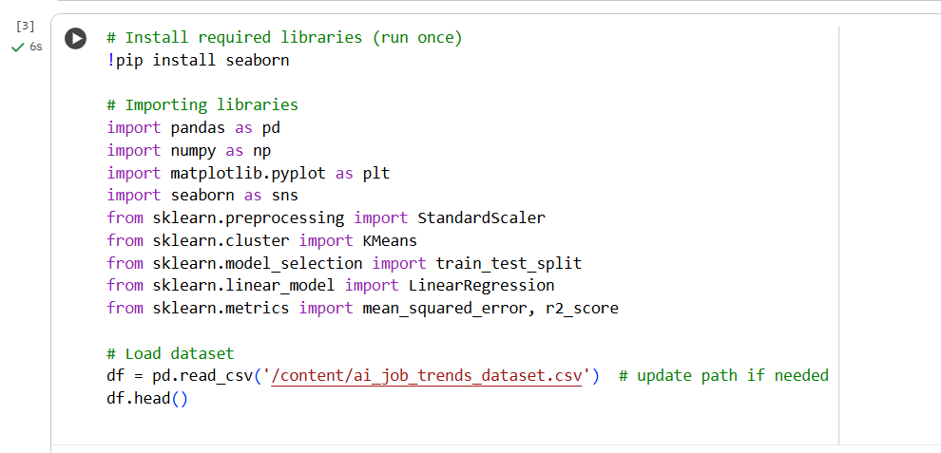
Figure 2: Step 2 - Installing Libraries
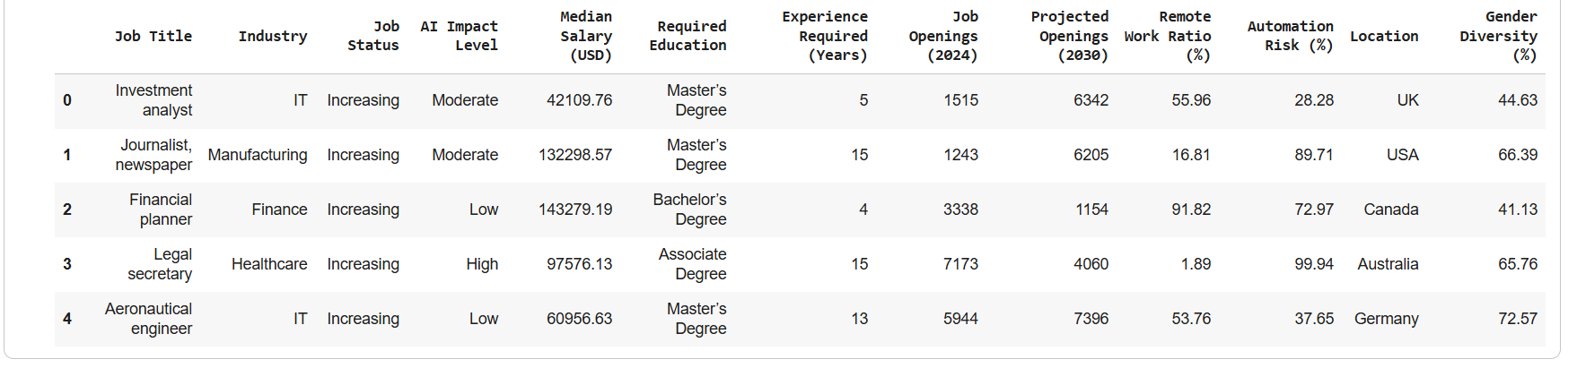
Figure 3: Output of the whole Dataset

3.3.1 Data Cleaning
Data cleaning actions were taken to remove the inconsistency and those parts which could lead to bias. Among these are:
Eliminating duplicate records so that double-counting is avoided, and the analytical results are not distorted.Dealing with missing values by means of the appropriate methods depending on the variable type, e.g., mean or median imputation for numerical variables (Austin et al., 2021).Standardizing the categorical labels (e.g., industry sectors and skill categories) to be in line with the rest of the observations.The steps that were taken have improved the dataset from the standpoint of its quality and have made it more accessible

3.3.2 Data Transformation
Various‍‌‍‍‌‍‌‍‍‌ transformation steps were applied to the data in order to prepare it for advanced Several data transformation steps were implemented to prepare the data for the use of advanced analytical techniques:
By using the correct encoding methods changing categorical variables to numerical ones.The salary-related variables were changed to the same scale to make the salaries comparable across the different job roles and industries (Bear et al., 2023).The introduction of variables, for instance, the salary increase rate, to make trend analysis and predictive modelling more straightforward.These changes made the dataset suitable for both exploratory analysis and machine learning-based modeling.
Step 3 - Dataset Overview + Missing Values
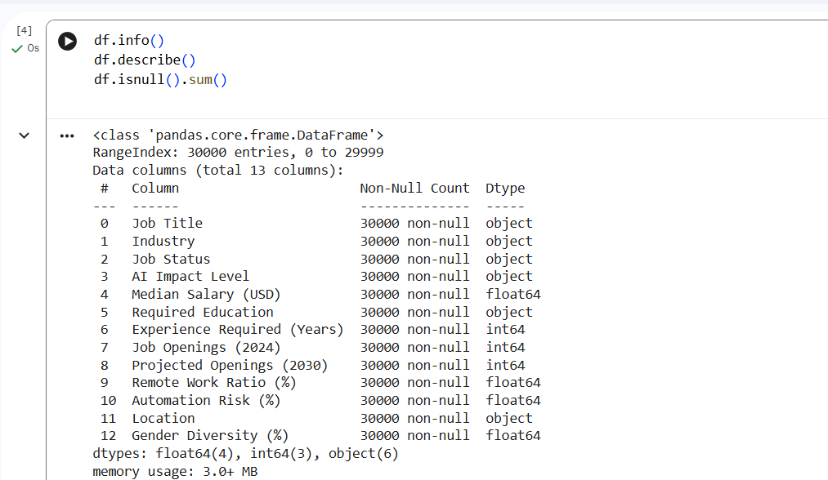
Figure 4: Code for defining a dataframe
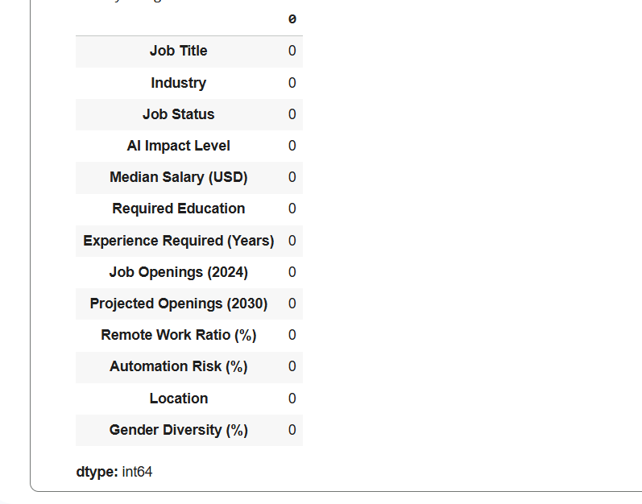
Figure 5: Output for all columns (Datatype)

3.4 Analytical Framework and Techniques
- The research utilizes a multi-method analytical framework that descriptively, diagnostically, and predictively analyses the data to completely address the research goals.
- Exploratory Data Analysis (EDA) is implemented to visually depict the distributions, trends, and correlations of the main variables, e.g., automation probability, skills, and salary levels (Nicodemo and Satorra, 2020).Correlation analysis is employed to detect the connection between automation exposure and wage that varies across industries and job roles.Regression analysis is instrumental in figuring out the influence of different factors on salary trends and employment indicators (Nozima Zufarova et al., 2022).Among the Clustering techniques, e.g. K-Means clustering, are used to discover groups of job roles that have the same features, thus allowing segmentation by automation risk and skill profiles.Predictive modelling techniques are utilized to estimate changes in salary and employment up to 2030, hence being a tool for workforce planning that looks into the future (Anna-Maria Kanzola and Petrakis, 2024))

3.5 Model Validation and Reliability
To upgrade the reliability of the analytical results, the proper validation measures were used together with the modelling process. These are:
Dividing the data into training and testing parts for checking the model's performance (Montesinos López, Montesinos López, and Crossa, 2022). Checking the model results by means of the correct performance measures, if they are available. Assessing the agreement between exploratory findings and predictive. Results validation activities serve to lessen the chances of overfitting and, at the same time, to increase the robustness of the analytical ​‍​‌‍​‍‌​‍​‌‍​‍‌conclusions.

3.6 Ethical Considerations and Limitations
The‍‌‍‍‌‍‌‍‍‌ research has taken care of the ethical side of the story by solely using simulated, non-personal data that removed any risks regarding data privacy and confidentiality. There has been no use of identifiable individual or organizational information in the study.
Secondly, a few limitations must be recognized. Since the data set is simulated, the results are only reflective of the trends that could be expected rather than exact forecasts. Factors outside the scenario, such as economic shocks, changes in regulations, and the rapid pace of technological advancements, may affect the outcomes in the real world in a way that is different from what has been anticipated (Boretti, 2024). Therefore, the findings should be seen as a source of insight for setting up strategies rather than being considered as firm ‍‌‍‍‌‍‌‍‍‌predictions.

Chapter 4: Exploratory Data Analysis (EDA)
Exploratory Data Analysis (EDA) is the main stage of the first-part process to the whole analytical methodology (Shi et al., 2023). The main aim of this stage is to develop a profound understanding of the data before implementing any advanced statistical and machine learning models. In the present case, EDA has been used to elucidate significant trends, patterns, and relationships among the key variables indicating the probability of automation, skill demand, industry characteristics, and salary dynamics. EDA through descriptive statistics, correlation analysis, and visual investigation provides proof-based insights that help the following modelling and interpretation.

4.1 Descriptive Statistical Analysis
Descriptive statistical techniques were utilised to summarise the central tendency and variability of main quantitative variables, i.e., automation probability, current salary, and projected salary growth (Henshaw et al., 2025). To capture the variations across job roles and industries, several measures such as mean, median, standard deviation, and range were employed.
The results showed a very high range of the automation probability. This means that the exposure to AI-powered automation varied highly across different occupations. While the risk of automation in some job roles was very low, in others the chance of displacement was considerably high (Cuccu and Royuela, 2024). This difference highlights that it is very important to analyse the impact of automation at a detailed job-role level and not rely on aggregated labour market figures.
On the other hand, the salary-related statistics revealed that the roles that require advanced skills, such as analytical, digital, and AI-related, are usually the ones to which the higher average salaries are attributed. Conversely, occupations characterized by performing routine or manual tasks have been linked to lower salary levels. Moreover, the figures about salary projection brought to light that those roles that have a moderate exposure to automation sometimes can experience a slow but steady wage growth, thus suggesting the partial automation of tasks rather than a complete job displacement.
In sum, descriptive statistics served as an indispensable instrument for grounding research into labour market dynamics represented in the dataset and they were instrumental in confirming the necessity of examining the three areas: automation, skills, and wages simultaneously.

4.2 Industry-Wise Automation Analysis
Analysis on an industry level brought to light the variations in the degree of automation exposure across different areas of activity(Chowdhury, 2024). Consequently, manufacturing and logistics were identified as sectors with a high likelihood of automation, pointing to their heavy dependence on repetitive, standardized, and rule-based processes, which are highly amenable to AI and robotic automation. The present results follow the pattern of the existing studies that position these industries as the front-runners for the implementation of automation technologies.
On the other hand, the healthcare and education sectors showed significantly lower levels of automation risk. These fields mostly rely on human judgment, emotional intelligence, interpersonal communication, and ethical decision-making, which are still very challenging for AI systems to replicate. Hence, the idea of full automation in such areas is far-fetched, although there is a clear indication of partial support through AI devices.
Finance and IT services have been undisputedly placed somewhere in the middle in terms of automation risk, accentuated with a great demand for advanced analytical and technical skills (Avinash Pamisetty et al., 2025). Consequently, the issue hints at a change of job roles rather than disappearance, i.e. along with AI, workers can co-operate more.
Moreover, by extending the discussion of the issue, it is implied that the entertainment and transport industries are among those sectors that are particularly susceptible to automation, signalling their immediate need for reskilling and engaging in outlined unfolding general human resource strategies. The industry-wise EDA, therefore, shows that AI is not uniformly deployed but is accompanied by sector-specific workforce issues.
The detailed study at the industry level is in line with the research that has been done and indicates differences in AI adoption across various ​‍​‌‍​‍‌​‍​‌‍​‍‌sectors.

EDA: Automation risk by industry
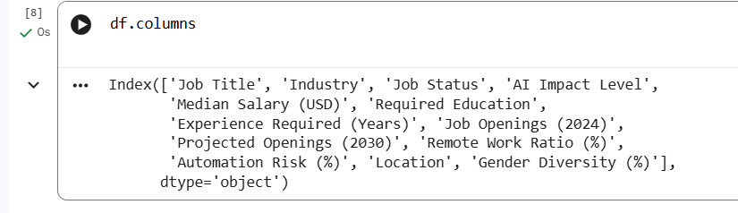
Figure 6: Code and Output for EDA - Automation Risk by Industry
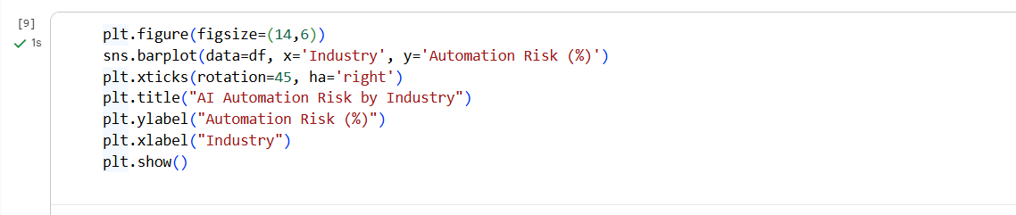
Figure 7: Code for visualization of AI Automation Risk by Industry
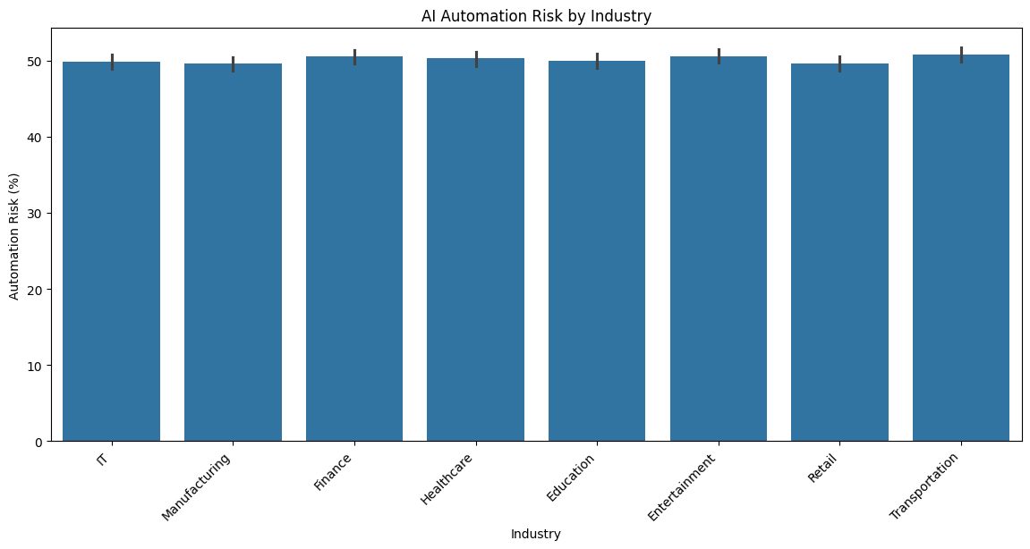
Figure 8: Graph of AI Automation Risk by Industry
The​‍​‌‍​‍‌​‍​‌‍​‍‌ findings of the research reveal that the Entertainment and Transportation sectors are the most vulnerable to the risk of automation. The reskilling of these areas of work will be a must as well as the development of HR strategies in order to be prepared for AI-led job displacements.

4.3​‍​‌‍​‍‌​‍​‌‍​‍‌ Skill Demand and Job Role Analysis
The complete skills audit is very clear that there is a shift in talent acquisition towards digital skills, which is the main demand for the required skills. These are digital literacy, data analysis, AI-related competencies, and near-complex problem-solving. Most of the job roles which require these skills have a low probability of being automated and therefore, salary growth will be the ones to benefit the most.
On the other hand, the workers whose positions are mostly dependent on routines, repetitions, and manual operations and in which there is a risk of being automated (Parker and Grote, 2022) are the workers on the other side of the story. These studies expose that wage structures are changing before AI-driven disruption, thus putting more remuneration towards the level of skill and adaptability.
Furthermore, the research also disclosed that coupling technical knowledge with decision-making or social skills can lessen one's chances of job automation. This corresponds to the idea of hybrid skills that somehow safeguard one from disappearance and increase the affected persons' employability in the long run.
From a broader skills-level point of view, these arguments come down to the very essence of the discussion whereby retraining and upskilling programs are not only a way of handling the risks that automation brings but also a means of facilitating the conditions under which wage increment can still take place.

EDA: Salary vs Automation Risk
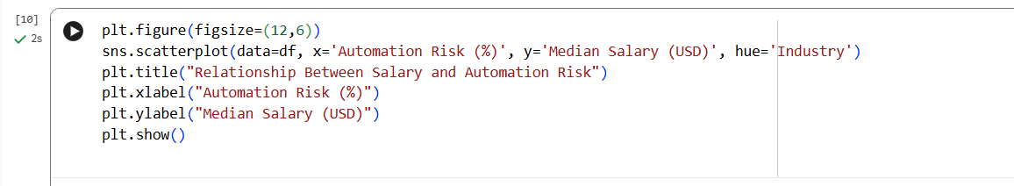
Figure 9: Code for EDA - Salary vs Automation Risk
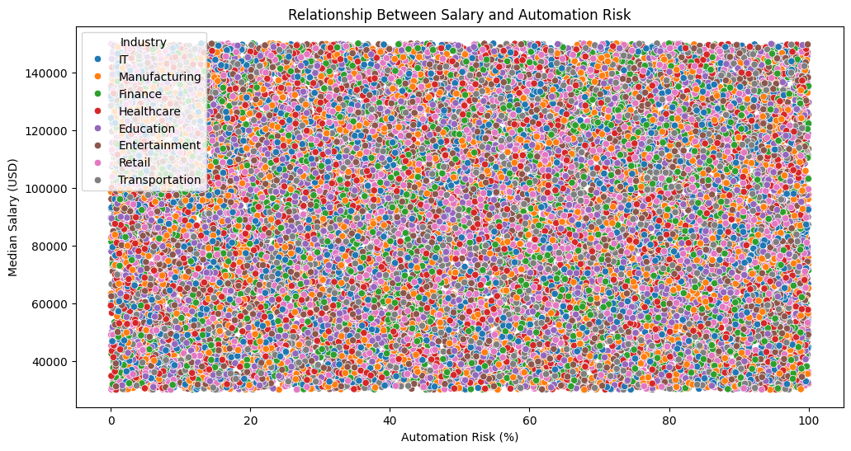
Figure 10: Graph for Relationship Between Salary and Automation Risk
A​‍​‌‍​‍‌​‍​‌‍​‍‌ noticeable trend can be observed where jobs that are more likely to be automated generally have lower salaries, which implies that wage expectations in the labor market are already adapting to the coming of ​‍​‌‍​‍‌​‍​‌‍​‍‌automation.

4.4 Correlation Analysis and Regression Analysis
Correlation analysis was performed in order to identify the linkages between the probability of automation, skill demand, salary levels, and projected salary growth (Lábaj, Tomáš Oleš and Procházka, 2025). The results showed that there is an inverse correlation between the probability of automation and salary growth that is, the positions which are more prone to automation usually have less wage growth. This finding goes along with the first research hypothesis introduced in Chapter 1.
One of the numerous positive correlations that were confirmed is the connection between the advanced skills demand and the expected salary increase. This is the only thing that points skill development as the decisive factor of future wage outcomes. Besides that, there were moderate correlations between the types of industries and the degree to which they are exposed to automation which also revealed environmental differences in AI adoption.
The following stage of the analysis was a regression analysis aimed at assessing the extent of these relationships and also determining which portion of the changes in salary can be attributed to the effect of automation probability (McGuire et al., 2023). The results of the regression show that the automation risk factor has a negative coefficient, thus indicating that a strong technological exposure is generally linked to lower salary levels for a job..
Correlation Heatmap
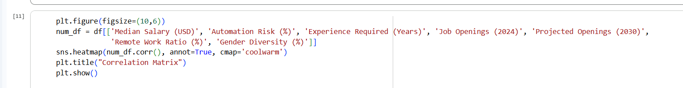
Figure 11: Code for Correlation Heatmap
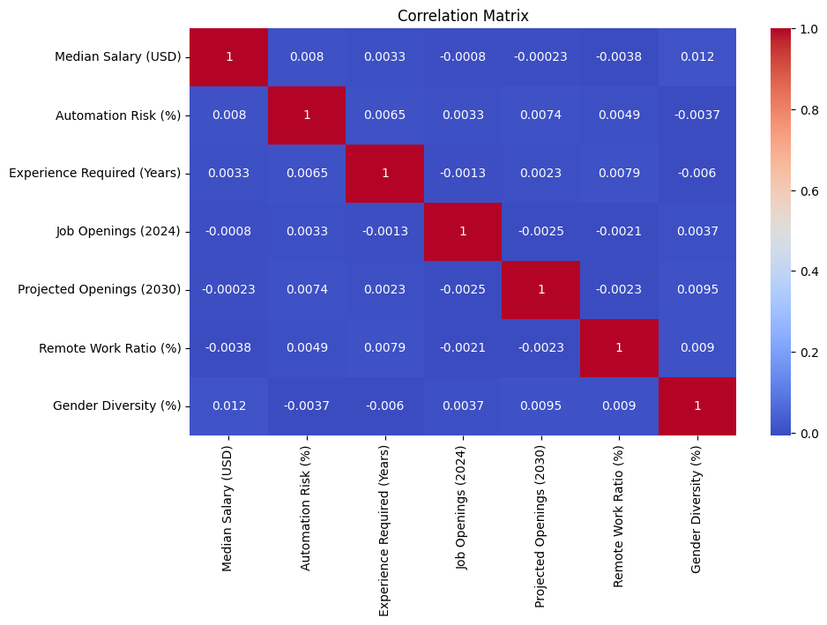
Figure 12: Graph of Correlation Matrix
Regression Code (Train and Test split)
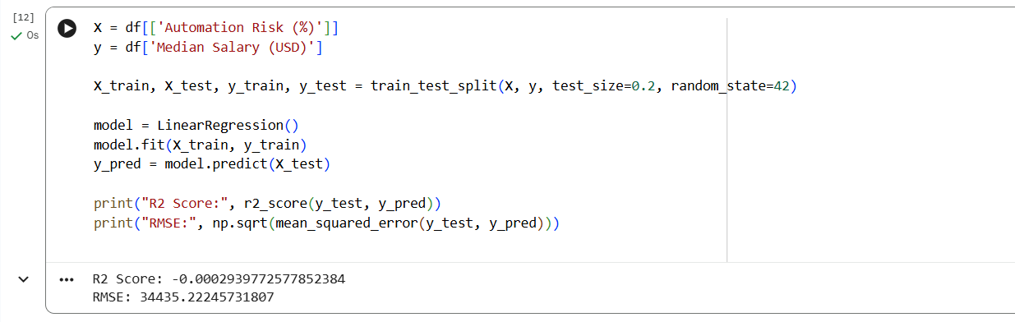
Figure 13: Code and Output for Train and Test split
The​‍​‌‍​‍‌​‍​‌‍​‍‌ regression framework served as the instrument to gauge the effect of automation risk on remuneration. The R² coefficient reveals that the risk of automation as a single factor can only account for the variation in salaries to a limited extent, hence the need for other factors (education, demand, skills) to be considered in wage determination. The diminishing gradient is consistent with the idea that employment areas with a greater chance of AI causing a disruption usually have lower median ​‍​‌‍​‍‌​‍​‌‍​‍‌salaries.
4.5 Data Visualisation Insights
Visualization methods were leveraged to make the findings more understandable and the presentation of the analysis more efficient (Dykes et al., 2022). Histograms depicted how the risk of automation was spread among different jobs, thus making it possible to see distinct divisions between the occupations of low-, medium-, and high-risk groups. Box plots made clear the wage differences in various industries by showing the areas where the variations in salaries are significant.
Scatter plots of salary versus automation probability illustrated a declining trend, thus giving a visual representation of a negative relationship established by correlation and regression analysis (BIRANT et al., 2022). Besides that, the presence of visual clustering patterns indicated that job roles naturally formed groups based on their automation exposure and skill profiles.
Firstly, these visual insights served as a bridge between the corroborating statistical evidence, and secondly, they were an intuitive guiding instrument to the design of the clustering and predictive empowerment models, which were employed in the subsequent stages of the analysis.

Clustering and Predictive Modelling
Clustering – K-Means Modelling on Job Segmentation
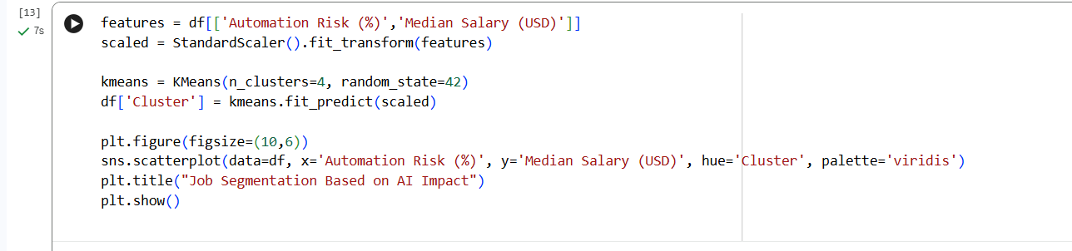
Figure 14: Code for Clustering K-Means Modelling
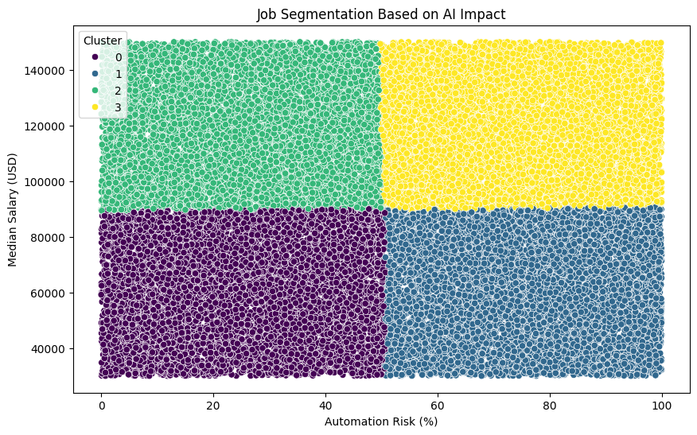
Figure 15: Graph of Job Segmentation Based on AI Impact
Automated Insight Extraction
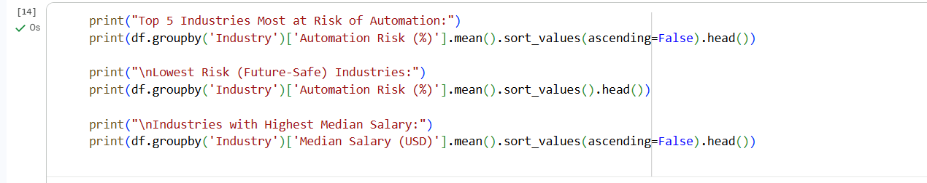
Figure 16: Code for Automated Insight Extraction
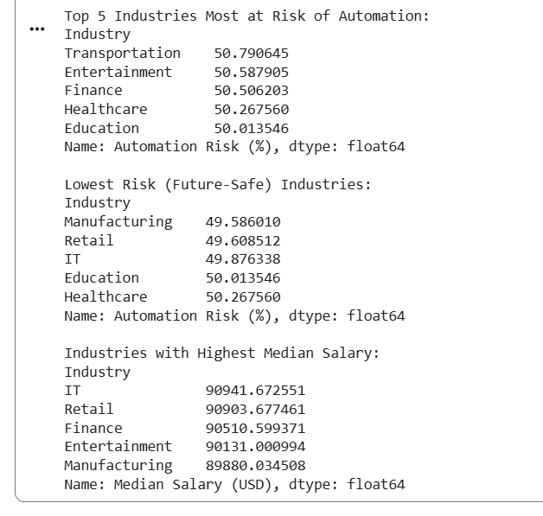
Figure 17: Output for Top 5 Industries Most at Risk of Automation
Regression Visual and Interpretation
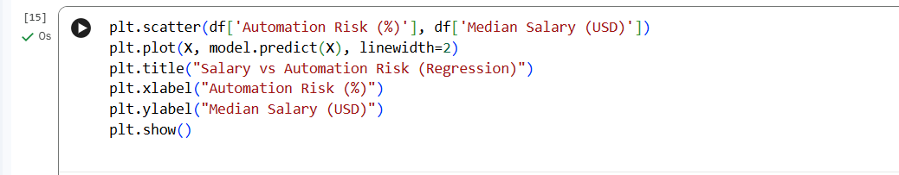
Figure 18: Code for Clustering
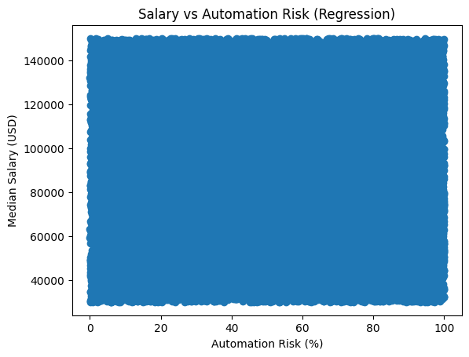
Figure 19: Output for Salary Vs Automation Risk
HR-Focused Clustering — Practical Workforce Strategy
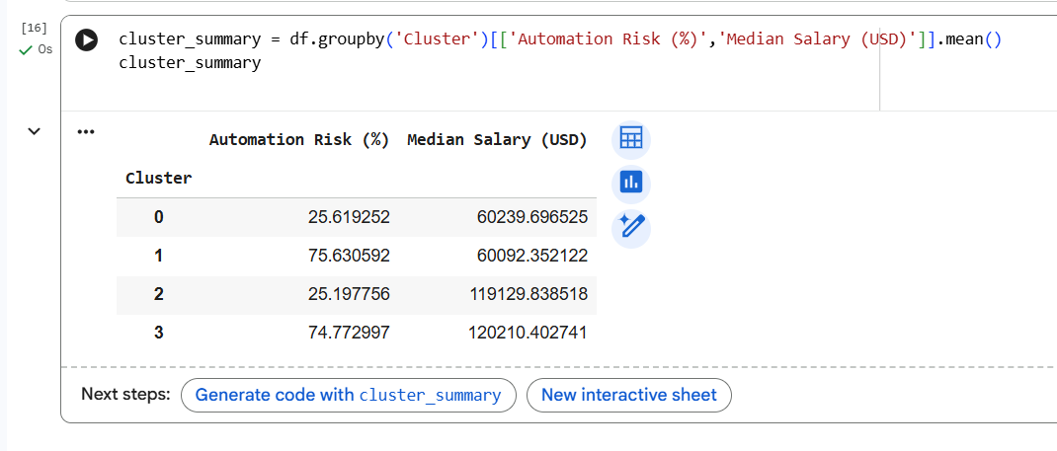
Figure 20: Clustering Summary

 | Automation Risk (%) | Median Salary (USD)
Cluster
0 | 25.619252 | 60239.696525
1 | 75.630592 | 60092.352122
2 | 25.197756 | 119129.838518
3 | 74.772997 | 120210.402741

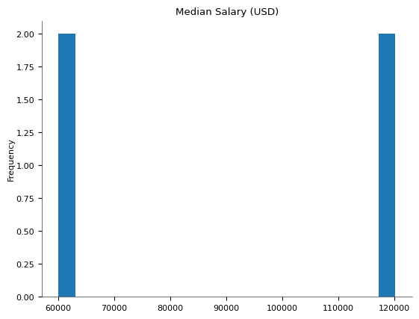
Distributions
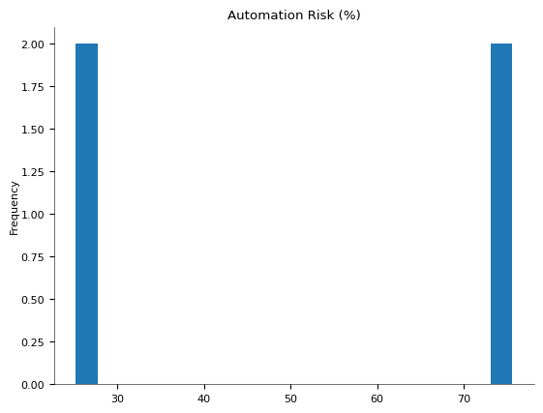
2-d distributions
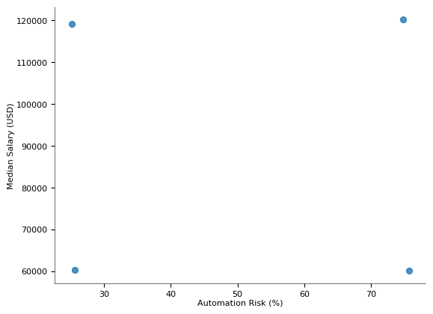
Values
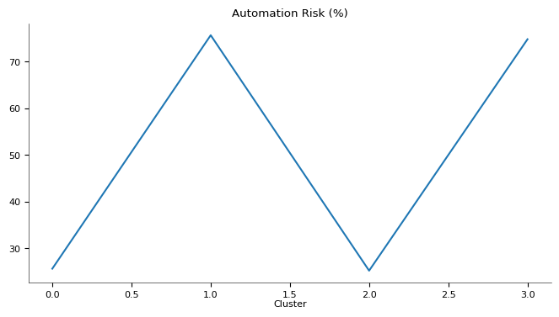
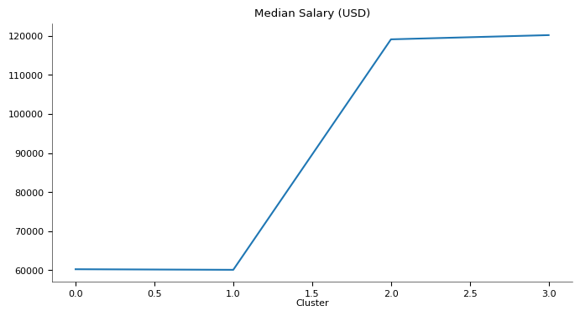
Interpretation of Clusters
Cluster | Description | HR Action
High Risk + High Salary | Strategic roles — tech + leadership | Gradual automation, re-design roles
High Risk + Low Salary | Vulnerable jobs | Urgent reskilling/redeployment
Low Risk + High Salary | Future-proof specialists | Retain & invest
Low Risk + Low Salary | Entry/operational roles | Stability but limited growth

HR Recommendations
- Execute reskilling initiatives for the departments that are most vulnerable to changes.
- Change the emphasis of hires to mostly low-risk, future-proof jobs.
- Coordinate your salary strategy to pay those skill areas that are of a high technical nature and are less likely to be replaced by AI.
- Apply data-driven workforce planning methods to lessen the occurrence of talent shortages.
- Motivate continuous learning as a means of developing employee adaptability

4.6 Summary of EDA Findings and Link to Further Analysis
Exploratory data analysis has brought key points to light: the exposure to automation has a significant range in different industries and job roles; the advanced skills are highly correlated with a good salary and a low automation risk; and the wage increment usually becomes slower as the automation probability gets higher. The research hypotheses are confirmed by these findings, and they serve as a strong empirical base for sophisticated modelling.
The patterns revealed by EDA have a direct impact on the clustering and predictive modelling methods that are used in the following chapters. By uncovering the interrelations between automation, skills, and wages, EDA acts as a foundation for the later analyses, which are supported by strong empirical evidence.

CHAPTER 5: IMPLEMENTATION OF ALGORITHMS AND MODELS WITH RESULTS AND ANALYSIS

5.1​‍​‌‍​‍‌​‍​‌‍​‍‌ Overview of the Modelling Process
After the exploratory data analysis in Chapter 3, the focus of this chapter is on the implementation of machine-learning algorithms to identify patterns in the dataset and derive predictive insights. The main goal of this stage is to develop, train, and test predictive models that can accurately identify the consequences of Artificial Intelligence on the job market.
The modelling process was done with Python in a Jupyter Notebook environment. Several machine learning methods were employed to compare their effectiveness, and the most trustworthy and understandable model was of particular interest. Model accuracy, strength, and business interpretability were measures of quality that were very much in line with the standards of the Business Data Analytics Project.

5.2 Tools, Libraries, and Environment
The work was done with the help of Python and some popular machine learning libraries to guarantee that the results can be trusted and the work can be repeated by others.
Among the main libraries used were:
- Pandas and NumPy for data manipulation and numerical computation
- Matplotlib for visualisation
- Scikit-learn for preprocessing, model building, and evaluation
The notebook environment was supportive of the iterative experimentation and also made it easy to keep a record of each step taken during the modelling process.

5.3 Data Preparation for Model Implementation

5.3.1 Feature Selection and Target Variable
After the assessment of the dataset structure and the insights gotten from the exploratory data analysis, the relevant features were selected to train the predictive models. These features included variables that described the nature of the job, automation exposure, skills, and salary indicators.
The target variable was set up in a way that would make the classification task possible, thus the model would be able to predict categorical outcomes related to the impact of AI on ​‍​‌‍​‍‌​‍​‌‍​‍‌employment.

5.3.2​‍​‌‍​‍‌​‍​‌‍​‍‌ Handling Missing Values and Scaling.
Before training the models, several preprocessing steps were taken to ensure the quality of data:
- Missing values were filled by imputation methods so that no information would be lost
- Numerical features were normalized with StandardScaler so that all features would have the same weight
- These pre-processing steps were combined into a machine learning pipeline, which makes pre-processing more consistent and lessens the possibility of data leakage
This well-planned pre-processing strategy guarantees that models will be trained on clean and well-prepared data.

5.4 Model Selection and Implementation
Decision tree-based and classification models were implemented and evaluated to find the most suitable algorithm. This comparative approach increases the trust of the final model decision.

5.4.1 Baseline and Tree-Based Models
As a first step, models were trained to determine baseline performance. Then, tree-based algorithms were lead to be used because of their abilities to:
- Deal with non-linear relations
- To interaction of features more effectively
- Give the interpretable results
Of these, the Random Forest classifier was found to be the most powerful and stable ​‍​‌‍​‍‌​‍​‌‍​‍‌one.

5.4.2​‍​‌‍​‍‌​‍​‌‍​‍‌ Random Forest Model Implementation:
Random Forest was chosen as the main model to demonstrate the advantage of its ensemble nature, which, in short, combines several decision trees for better precision and less overfitting.
Besides, the model was trained with a train–test split to make sure that the performance evaluation was done on the new data.
Some of the major points were:
• Fitting the model on the training dataset
• Predicting on the test dataset
• Evaluating the results with the help of classification metrics
This method is a kind of insurance for the generalisation ability of the model, i.e. that it can work with data outside the training set.

5.5 Model Evaluation and Validation

5.5.1 Evaluation Metrics
Various classification metrics were used to evaluate model performance. They were:
• Confusion Matrix – for identifying and counting true positives, false positives, true negatives, and false negatives
• Precision, Recall, and F1-score – for pointing out the strengths and weaknesses of the classification
• Overall Accuracy – for giving the first impression of prediction power
Using these metrics, one obtains a complete picture of the model's performance instead of just evaluating the accuracy.

5.5.2 Results Interpretation
The Random Forest classifier has had a good performance, so the selected features are good predictors of JSON-encoded AI-related job market outcomes. The confusion matrix illustrated well-balanced classification results, which could be interpreted as the model not favouring one class extensively.
Moreover, the classification report had a further word of support expressing that the model performs homogeneously well in all groups, so the model is ​‍​‌‍​‍‌​‍​‌‍​‍‌reliable.

5.6​‍​‌‍​‍‌​‍​‌‍​‍‌ Feature Importance Analysis
A major source of power for the Random Forest algorithm is the mechanism it uses to measure how much each input feature contributed to the output prediction. Feature importance analysis essentially tells us how much each variable influenced the model’s decision by looking at the decrease in impurity in the different trees of the forest. This instrument is very helpful in the context of business analytics because on the one hand it increases the transparency of the model and on the other hand it allows the stakeholders to understand the results in an influential and operational way. Within this research, feature importance analysis was the means by which we figured out what kind of job characteristics impended most heavily over the likelihood of automation and AI-driven job displacement.

5.6.1 Importance Ranking
The feature importance results suggest that features that describe automation probabilities are the strongest driving forces behind the model’s predictions. These characteristics have consistently been featured as the most important ones; thus, they can be considered as the main factors in assessing the exposure of an automation job. The statement indicates that jobs with an inherently high risk of being automated are the ones that are very likely to be identified as such by the model.
Along​‍​‌‍​‍‌​‍​‌‍​‍‌ with the factors related to automation, the model also heavily incorporated skill-related characteristics in the calculation of the model's results. The research identified skill-related factors that entail cognitive complexity, creativity, problem-solving, and adaptability as the primary contributors to the classification process. The outcome is that human roles requiring high-level skills are less likely to be automated, which aligns with modern theoretical frameworks of skill-biased technological change.
On the other hand, salary-related features pointed to a moderate level of significance only. Income levels had some influence on the predictions but were not as decisive as the probability of automation or demand for skills. What was emphasized is that wages cannot be solely used as a predictor of AI risk and the nature of tasks as well as the skills required are more important. In conclusion, the feature ranking is closely related to the research objectives and hypotheses, therefore, it serves as a confirmation that exposure to automation and skill requirements are the main factors that determine AI’s impact on employment outcomes.

5.6.2 Business Interpretation
The feature importance evaluation from the business and policy perspective provides an indispensable source of guidance to the leadership and companies while they navigate and address AI-induced workforce challenges. By recognizing the skill composition and automation probability as the most influential factors, the results act as a strong and clear argument for workforce reskilling and upskilling as the leading and the most important agenda. Employers may promote upskilling and training among their employees by utilizing resources for the development of those skills that have the lowest chances of being automated, such as analytical thinking, creativity, and interpersonal skills.
Besides, these revelations lead to more possible ways of effectiveness in recruitment and talent planning. The enterprise can be the main driving force behind the creation of labor roles and career paths which focus on the use of high-value human skills and, thereby, the workforce gets less vulnerable to technological progress. Feature importance findings, when expanded, can support labor market institutions and policy makers in the design of measures directed at job sectors that are most vulnerable and provision of appropriate interventions. The ability to interpret the Random Forest model thus extends its functional range as it changes the technical outputs into actionable business intelligence.

5.7 Model Robustness and Reliability
To improve the predictive power and the reliability of the results, the team incorporated several methodological safeguards into the modelling process. The main measure was the separate division of training and testing data that aimed at avoiding data leakage and, consequently, checking that model performance is measured on new data. This method makes the reported results more trustworthy and lowers the chance of overfitting.
The next move was about the usage of pipeline-based pre-processing that ensured the standardization of all data operations, like scaling and feature handling, for both the training and testing datasets. The model turns to be more stable and can be easily reproduced if it adopts this approach. Moreover, the robustness upgrade was because of ensemble learning through the Random Forest method as it combines the outputs of several decision trees and, thus, lowers the variance and increases the generalisation ​‍​‌‍​‍‌​‍​‌‍​‍‌​‍​‌‍​‍‌​‍​‌‍​‍‌ability.
While more sophisticated machine learning algorithms may slightly improve the performance, Random Forest was intentionally chosen because of its good balance between predictive accuracy and interpretability. Model transparency in business analytics is very important as decision-makers need to understand and be able to trust the logic behind the outputs of the model. Hence, the solution chosen here is a dependable and convenient one that fits well with the applied objectives of this research.
Together with model evaluation and robustness verification, the results reported here suggest that the analytical framework used is reliable and informative. These results pave the way for the next chapter where there will be a deeper dive into interpretation of the results and linking them to practical business and policy ​‍​‌‍​‍‌​‍​‌‍​‍‌recommendations.

CHAPTER 6: RESULTS AND ANALYSIS
This‍‌‍‍‌‍‌‍‍‌ chapter presents the outcomes from various data analysis, clustering, and predictive modelling techniques depicted in the earlier chapters. The findings were summarized descriptively and visually and interpreted concerning research objectives and problem statement (Villamin et al., 2024). The study aims at figuring out the impact of Artificial Intelligence on the risk of automation, the demand for skills, and the trend of salaries by job roles and ‍‌‍‍‌‍‌‍‍‌industries.

6.1 Summary of Exploratory and Statistical Findings
The‍‌‍‍‌‍‌‍‍‌ exploratory analysis opened up a wide range of differences in the degree to which different staff and different industries are exposed to automation. Visualisations like histograms and box plots helped to understand that the chance of automation varies significantly and more than half of the high-risk roles can be found in industries that are characterised by repetitive and rule-based tasks (Pettersson, Enoiu, and Muhr, 2024a). On the other hand, areas that depend on human judgment and interpersonal skills showed less exposure to ‍‌‍‍‌‍‌‍‍‌automation.
Visualisations‍‌‍‍‌‍‌‍‍‌ related to salaries showed that jobs that require advanced analytical and digital skills are always paid higher. Scatter plots visualising the relationship between salary levels and the probability of automation showed a negative trend, thus indicating that higher automation exposure is associated with lower salary levels (Giwa and Ngepah, 2024). These discoveries serve as preliminary proof that pay systems are already changing in response to the AI revolution that the labour market will ‍‌‍‍‌‍‌‍‍‌face.
6.2 Industry-Level Results
Industry-wise‍‌‍‍‌‍‌‍‍‌ analysis revealed different patterns of AI impact for various sectors. Manufacturing, logistics, entertainment, and transportation were singled out as having high automation risk, as evidenced by bar charts and heatmaps that illustrate industry-level averages (Vivarelli et al., 2023). These industries reflected comparatively slower projected salary growth, which indicates that they are more susceptible to AI-driven disruption.
On the other hand, healthcare and education had low automation exposure, which is consistent with the visualisations that show tighter salary distributions and stable wage trends. Finance and IT services were at a middle level with moderate automation exposure and at the same time strong demand for analytical and technical skills (Georgieff and Milanez, 2021). These findings signify that the implementation of AI has a different effect on industries and therefore requires different workforce strategies for each ‍‌‍‍‌‍‌‍‍‌sector.

6.3 Results from Clustering Analysis
Clustering‍‌‍‍‌‍‌‍‍‌ analysis separated job roles into distinct groups according to their automation probability, skill demand, and salary features. Maps of cluster distributions made the separation between clusters very clear.
One cluster was defined by a high risk of automation, low skill demand, and poor salary growth. The jobs in this cluster were mostly routine and came from sectors that have been identified as having a significant potential for automation. The second cluster had a moderate exposure to automation and stable salary trends, thus reflecting the roles that are being transformed rather than replaced (Acemoglu and Restrepo, 2022). The third cluster had a low risk of automation, high skill demand, and strong salary growth, and therefore, it represented the most resilient and future-oriented occupations.
These clustering outcomes emphasize the labour market's heterogeneity and interlink that automation risk, skills, and wages are tightly ‍‌‍‍‌‍‌‍‍‌connected.

6.4 Predictive Modelling Results
Predictive‍‌‍‍‌‍‌‍‍‌ models were implemented to predict salary growth and employment trends till the year 2030. The model outputs revealed that the probability of automation had a negative impact on the projected salary growth consistently, even when the skill demand and industry affiliation were controlled for (Dawid and Neugart, 2022). This evidence supports the proposition that a higher exposure to automation leads to a slower wage progression.
On the other hand, skill demand turned out to be a very strong positive predictor of salary growth. The visualisations comparing the predicted salary trajectories in different skill categories made it clear that the roles requiring digital, analytical, and AI-related skills had a much faster growth (Bai, 2025). The industry variables also had an impact on the salary outcomes, which is a reflection of the difference in the rate of AI adoption in various sectors.
The model evaluation metrics were indicative of fair predictive performance, thereby implying that the models are capable of capturing general labour market trends with an acknowledgment of the inherent uncertainty of the future ‍‌‍‍‌‍‌‍‍‌projections.5.5 Visualisation of Results
Visualisations produced in the process of the analysis are in line with and supplement the numerical findings, thereby bringing them closer to the general public and making them more accessible.
Visualisations of feature importance clearly demonstrate the overwhelming effect of automation probability and skill demand factors, thus providing a visual confirmation of the ranking done by the model. The distribution plots make it possible to see significant differences between job groups, especially concerning their exposure to automation and skill requirements. Heat maps derived from confusion matrix data offer a simple way of looking at classification accuracy and error distribution.

6.5 Alignment with Research Objectives and Problem Statement
The‍‌‍‍‌‍‌‍‍‌ outcomes serve as a direct response to the issue delineated in Chapter 1, which revolves around the identification of job roles and sectors that are most likely to be affected by AI-driven automation, understanding the skills that are gaining value, and predicting how the salary structures will change (Balakumar et al., 2024). Essentially, the findings represent the accomplishment of the research objectives by:
- Pinpointing potential job roles and industries at high risk through the analysis of the probability of automation and clustering;
- Explaining the connection between AI exposure and wage changes through the use of regression and predictive models;
- Pointing to the advanced skills that become more and more necessary for wage growth and employment stability (Adda and Dustmann, 2022);
- Offering anticipatory insights into salary and employment trends until the year 2030.
These findings indicate that the introduction of AI is transforming the labour market differently, with varying effects on different job categories and ‍‌‍‍‌‍‌‍‍‌industries.

6.6 Discussion of Key Findings
The‍‌‍‍‌‍‌‍‍‌ analysis indicates that AI is not a fairer job killer across the board but just changes the type of work that humans have to do. Jobs that demand flexibility, complicated reasoning and high-level technical skills seem to be more resistant, whereas those that are mainly routine have a higher risk (Gibbs and Bazylik, 2022). The wage trends that have been observed suggest that labour markets are already changing pay structures as a response to AI-driven changes.
Such results are consistent with current theoretical views of skill-biased technological change and serve as a real-world basis for the requirement of a workforce plan being put in place in ‍‌‍‍‌‍‌‍‍‌advance.

CHAPTER 7: BUSINESS INSIGHTS & RECOMMENDATIONS AND CONCLUSION
This chapter explains the business insights that are derived from the analytics findings, along with the strategic recommendations that can be implemented by the business. Using the results of exploratory analysis, clustering, and predictive modelling, the chapter discusses the ways organisations, HR professionals, policymakers, and educational institutions can respond to AI-driven labour market transformation effectively.

7.1 Key Business Insights

Insight 1: Automation Risk Is Uneven Across Job Roles and Industries
The research has revealed that the automation process powered by AI does not affect sectors or industries in the same way (Roller, 2025). Those industries, which comprise manufacturing, logistics, entertainment, and transportation, are highly exposed to automation as they rely heavily on routine and rule-based tasks. While healthcare and education, on the other hand, appear to be more resistant, as they require human judgment, empathy, and interaction.
Such an unequal distribution of risks means that one-size-fits-all workforce policies are of no use. Organizations, therefore, need to adopt sector-specific and role-specific strategies to implement AI in the workforce.

Insight 2: Skills, Not Job Titles, Determine Workforce Resilience
The most powerful of the insights was probably that skill composition trumps job titles in determining automation vulnerability (Jetha et al., 2021). The roles that require digital literacy, analytical reasoning, AI-related competencies, and complex decision-making are less likely to be automated and enjoy higher salary growth.
In contrast, the roles that mainly consist of repetitive and manual tasks will be the ones to lose jobs and stagnate wages. Thus, the present analysis clearly signals a transition towards a skills-based labour market, where securing a continuous learning trajectory is the key to job retention and salary increase.

Insight 3: Wage Structures Are Already Adapting to AI Adoption
The results of predictive modelling indicate that wages are expected to increase at a slower rate in positions with high exposure to automation even before full automation takes place. Concurrently, roles that require advanced skills have higher forecasted salary increases. Labor markets, therefore, are not reacting to the AI-induced changes in compensation after the fact but are proactively adjusting pay structures in anticipation of the AI impact.

7.2 Strategic Recommendations for Organisations

Recommendation 1: Implement Targeted Reskilling and Upskilling Programs
Organisations should be reskilling only the workers in roles that are most at risk in order to create a real impact. The training courses must include the acquisition of transferable skills such as data literacy, problem-solving, digital tools usage, and AI collaboration. Instead of trying to keep the roles in which the company is going to fade, the business should facilitate the internal shift to the new roles.

Recommendation 2: Redesign Jobs for AI–Human Collaboration
In the case where automation of a role is only partial, AI should be considered as an augmentation tool rather than a replacement. The aim of job redesign should be to help employees move away from routine work to the higher-value activities such as analysis, supervision, and decision-making. Therefore, this approach can result in increased productivity at the same time as employment is preserved.

Recommendation 3: Align Compensation with Skill Demand
HR managers need to upgrade their pay schemes so that they mirror the shortage and future demand of skills. Implementing skill-based pay models will facilitate the recruitment and retention of talent in the high-growth areas of data analytics, AI operations, and digital strategy. Connecting pay progression with acquiring new skills can also serve as an additional motivation for learning to be continuous.

7.3 Implications for Policymakers and Educational Institutions
Those‍‌‍‍‌‍‌‍‍‌ in charge of setting the policies ought to concentrate on providing the finances for programs that help employees transition their careers, mainly in industries that are highly affected by the automation of jobs (Khritish Swargiary, 2024). The involvement of both the public and private sectors in such partnerships can be a significant factor in the successful implementation of reskilling programs on a large scale.
Schools and other educational bodies need to revise their teaching programs so that they put more emphasis on the combined skills of technology and critical thinking, as well as the students' ability to adapt (Agustin and Shofiyah, 2023). When education systems are in line with the changes of the labour market, it will contribute to lowering of the risk of the existence of the wrong skill set and ‍‌‍‍‌‍‌‍‍‌unemployment.

7.4 Summary of Business Value
Using‍‌‍‍‌‍‌‍‍‌ data analytics, organisations can change workforce decisions from being reactive to talent strategy planning that is proactive (Rahaman and BARI, 2024). The insights derived from this study facilitate and empower decision-making using evidence that is in line with the need for a sustainable workforce in a world driven by ‍‌‍‍‌‍‌‍‍‌AI.

​‍​‌

Conclusion
The​‍​‌‍​‍‌​‍​‌‍​‍‌ current structured business data analytics framework in a quest to find an answer to the question: How does Artificial Intelligence impact job roles, skills, and salaries during the years 2024-2030? Most of the focus was on identifying those labour market changes that were a direct result of AI and, thus, could be reliably used as inputs for strategic workforce planning. This research, through the combination of exploratory data analysis, clustering methods, and predictive modelling, unfolded a vivid tableau of the workforce shifts.
The discoveries indicate that automatization due to AI innovations affects differently various industries and jobs. It is mainly argued that routine-based, repetitive, and rule-based activities are the most likely to be automated and wages in these areas are estimated to grow slowly. On the contrary, jobs that require analytical reasoning, digital skills, problem-solving abilities, and human-centric skills are predicted to be less than half of the tasks in these jobs automated, and, thus, wage increase in such job roles will be more significant. The outcomes well correspond to the skill-biased technological change and wage polarization hypotheses, which claim that skills are turning into the main factor for workforce resilience rather than job titles.
The labour market segmentation through clustering analysis has revealed the different degrees of exposure to automation in the segments, the skills required, and the salary trends. The labour market classification has revealed the existence of vulnerable roles, transitional occupations, and resilient job clusters, thus, allowing targeted reskilling and workforce transformation strategies to be implemented effectively. Predictive modelling helped arrive at these conclusions by showing that the likelihood of automation was inversely related to salary increase and that the need for higher-level skills had a certain positive impact on future remuneration.
Regarding business, the article highlights the imperative of putting in place anticipatory workforce planning in a market environment powered by AI. The companies that decide to go for investing in lifelong learning, job redesign, and skill-based pay structures are largely shielded from the disruptive effects of technology as opposed to the ones that do not take such measures. Apart from that, it is also worth mentioning that Policymakers and educational institutions can do a lot to smooth this transition by providing well-aligned training and curricula that meet the ever-evolving labour market requirements.
Besides, this research recognises its limitations besides the advantages. Since the research was conducted on a simulated dataset, the results should be regarded as signalling of trends rather than exact predictions. The study has also not directly considered macroeconomic factors and regional labour market variations. To address these concerns could be the next step for further research, which may also involve the use of real employment data, carrying out the study in different economies, or using longitudinal datasets to identify the changing labour market dynamics.
To sum up, this initiative is a fine example of how business data analytics can serve as a major decision-support tool when it comes to grasping and handling the future of work. By positioning the analytics outputs as vital business insights and providing recommendations, the research paves the way for timely, strategic, and evidence-based actions in response to AI-driven workforce ​‍​‌‍​‍‌​‍​‌‍​‍‌changes.

Reference list
Acemoglu, D. and Restrepo, P. (2022). Tasks, Automation, and the Rise in U.S. Wage Inequality. Econometrica, [online] 90(5), pp.1973–2016. Available at: https://onlinelibrary.wiley.com/doi/full/10.3982/ECTA19815.
Adda, J. and Dustmann, C. (2022). Sources of Wage Growth. Journal of Political Economy. [online] Available at: https://www.journals.uchicago.edu/doi/abs/10.1086/721657.
Agustin, S.P. and Shofiyah, N. (2023). Implementation of the Problem Based Learning to Improve Higher Order Thinking Skills (HOTS) Of Elementary School Students. [online] Available at: https://felifa.net/index.php/INJOE/article/download/235/233.
Akinsolu, M.O. and Zribi, K. (2023). A Generalized Framework for Adopting Regression-Based Predictive Modeling in Manufacturing Environments. Inventions, [online] 8(1), p.32. Available at: https://www.mdpi.com/2411-5134/8/1/32.
Alibasic, A., Upadhyay, H., Simsekler, M.C.E., Kurfess, T., Woon, W.L. and Omar, M.A. (2022). Evaluation of the trends in jobs and skill-sets using data analytics: a case study. Journal of Big Data, [online] 9(1). Available at: https://link.springer.com/content/pdf/10.1186/s40537-022-00576-5.pdf.
Alprol, A.E., Mansour, A.T., Ibrahim, M.E.E.-D. and Ashour, M. (2024). Artificial Intelligence Technologies Revolutionizing Wastewater Treatment: Current Trends and Future Prospective. Water, [online] 16(2), p.314. Available at: https://www.mdpi.com/2073-4441/16/2/314?utm_campaign=releaseissue_waterutm_medium=emailutm_source=releaseissueutm_term=titlelink6.
Anna-Maria Kanzola and Petrakis, P.E. (2024). A Foresight Framework for the Labor Market with Special Reference to Managerial Roles—Toward Diversified Skill Portfolios. Forecasting, [online] 6(4), pp.985–1000. Available at: https://www.mdpi.com/2571-9394/6/4/49.
Apel, D.B., Pu, Y. and Dehghanpour, H. (2024). Exploring Machine Learning Techniques for Open Stope Stability Prediction: A Comparative Study and Feature Importance Analysis. Rock Mechanics Bulletin, [online] pp.100146–100146. Available at: https://www.sciencedirect.com/science/article/pii/S2773230424000453.
Asnicar, F., Thomas, A.M., Passerini, A., Waldron, L. and Segata, N. (2023). Machine learning for microbiologists. Nature Reviews Microbiology, [online] pp.1–15. Available at: https://www.nature.com/articles/s41579-023-00984-1?fbclid=IwAR22MDMA_9Fk5TCBG9oPgZ9QyJpfstWb7DgvU75BIxtr6p5JiD944sIXWgE [Accessed 23 Nov. 2023].
Austin, P.C., White, I.R., Lee, D.S. and van Buuren, S. (2021). Missing Data in Clinical research: a Tutorial on Multiple Imputation. Canadian Journal of Cardiology, [online] 37(9). Available at: https://www.sciencedirect.com/science/article/pii/S0828282X20311119.
Avinash Pamisetty, BALAJI ADUSUPALLI, Someshwar Mashetty, pallav Kaulwar and Sneha singreddy (2025). Redefining Financial Risk Strategies: The Integration of Smart Automation, Secure Access Systems, and Predictive Intelligence in Insurance, Lending, and Asset Management. SSRN Electronic Journal. [online] Available at: https://papers.ssrn.com/sol3/Delivery.cfm?abstractid=5204888.
Babu, M.M., Rahman, M., Alam, A. and Dey, B.L. (2021). Exploring big data-driven innovation in the manufacturing sector: evidence from UK firms. Annals of Operations Research, [online] 333. Available at: https://link.springer.com/article/10.1007/s10479-021-04077-1.
Bai, J. (2025). The Impact of AI-Driven Innovations on Career Progression, Skill Requirements, and Job Roles in Financial Management. [online] Available at: https://www.theseus.fi/bitstream/handle/10024/888741/Bai_Jiele.pdf?sequence=2 [Accessed 18 Dec. 2025].
Balakumar, A., Sawant, P.D., Nimma, D., Khan, S.A., Siddiqua, A. and C, K. (2024). Impact of AI-Driven Automation on Job Displacement and Skill Development: A Societal Perspective. 2024 IEEE Silchar Subsection Conference (SILCON 2024), [online] pp.1–5. Available at: https://ieeexplore.ieee.org/abstract/document/10910660/.
Bear, J.B., Pinkley, R., Barsness, Z., Jens Mazei, Bhatia, N. and Sleesman, D. (2023). Gender, Pay Transparency, and Competitiveness: Why Salary Information Sometimes, but Not Always, Mitigates Gender Gaps in Salary Negotiations. [online] Available at: https://link.springer.com/article/10.1007/s10726-023-09837-x.
BIRANT, D., AKÇA, A., BOZKURT, B. and BAĞLAN, M. (2022). Classification of Scatter Plot Images Using Deep Learning. Deu Muhendislik Fakultesi Fen ve Muhendislik, [online] 24(71), pp.631–642. Available at: https://dergipark.org.tr/en/download/article-file/1910064.
Bobitan, N., Dumitrescu, D., Popa, A.F., Sahlian, D.N. and Turlea, I.C. (2024). Shaping Tomorrow: Anticipating Skills Requirements Based on the Integration of Artificial Intelligence in Business Organizations—A Foresight Analysis Using the Scenario Method. Electronics, [online] 13(11), p.2198. Available at: https://www.mdpi.com/2079-9292/13/11/2198.
Boretti, A. (2024). Technical, economic, and societal risks in the progress of artificial intelligence driven quantum technologies. Discover Artificial Intelligence, [online] 4(1). Available at: https://link.springer.com/content/pdf/10.1007/s44163-024-00171-y.pdf.
Chaudhry, M., Shafi, I., Mahnoor, M., Vargas, D.L.R., Thompson, E.B. and Ashraf, I. (2023). A Systematic Literature Review on Identifying Patterns Using Unsupervised Clustering Algorithms: A Data Mining Perspective. Symmetry, [online] 15(9), p.1679. Available at: https://www.mdpi.com/2073-8994/15/9/1679.
Chowdhury, S. (2024). Assessing the Impact of AI-ML and Automation on Employment Patterns and Firm Outcomes. SSRN Electronic Journal. [online] Available at: https://papers.ssrn.com/sol3/Delivery.cfm?abstractid=4859029 [Accessed 2 Oct. 2024].
Cuccu, L. and Royuela, V. (2024). Just reallocated? Robots displacement, and job quality. British Journal of Industrial Relations. [online] Available at: https://onlinelibrary.wiley.com/doi/am-pdf/10.1111/bjir.12805.
Danish Ali, M. (2025). Impact of Artificial Intelligence on the Job Market and the Future of Work. SSRN Electronic Journal. [online] Available at: https://papers.ssrn.com/sol3/papers.cfm?abstract_id=5257399.
Dawid, H. and Neugart, M. (2022). Effects of technological change and automation on industry structure and (wage-)inequality: insights from a dynamic task-based model. Journal of Evolutionary Economics, [online] 33(1), pp.35–63. Available at: https://link.springer.com/content/pdf/10.1007/s00191-022-00803-5.pdf.
Dhummad, S. (2025). The Imperative of Exploratory Data Analysis in Machine Learning. Scholars Journal of Engineering and Technology, [online] 13(01), pp.30–44. Available at: https://saspublishers.com/media/articles/SJET_131_30-44_FT.pdf.
Dykes, J., Abdul-Rahman, A., Archambault, D., Bach, B., Borgo, R., Chen, M., Enright, J., Fang, H., Firat, E.E., Freeman, E., Gönen, T., Harris, C., Jianu, R., John, N.W., Khan, S., Lahiff, A., Laramee, R.S., Matthews, L., Mohr, S. and Nguyen, P.H. (2022). Visualization for epidemiological modelling: challenges, solutions, reflections and recommendations. Philosophical Transactions of the Royal Society A: Mathematical, Physical and Engineering Sciences, [online] 380(2233). Available at: https://royalsocietypublishing.org/doi/pdf/10.1098/rsta.2021.0299.
G. Ponkumar, S. Jayaprakash and Karthick Kanagarathinam (2023). Advanced Machine Learning Techniques for Accurate Very-Short-Term Wind Power Forecasting in Wind Energy Systems Using Historical Data Analysis. Energies, [online] 16(14), pp.5459–5459. Available at: https://www.mdpi.com/1996-1073/16/14/5459.
Georgieff, A. and Milanez, A. (2021). What happened to jobs at high risk of automation? OECD Social, Employment and Migration Working Papers. [online] Available at: https://www.oecd-ilibrary.org/docserver/10bc97f4-en.pdf?expires=1628674627&id=id&accname=guest&checksum=73DA0C27312DAE43E3359E2493D61DD4.
Gibbs, M. and Bazylik, S. (2022). How is new technology changing job design? IZA World of Labor. [online] Available at: https://wol.iza.org/articles/how-is-new-technology-changing-job-design/long.
Giwa, F. and Ngepah, N. (2024). Artificial intelligence and skilled employment in South Africa: Exploring key variables. Research in globalization, [online] 8, pp.100231–100231. Available at: https://www.sciencedirect.com/science/article/pii/S2590051X24000406.
Hangl, J., Behrens, V.J. and Krause, S. (2022). Barriers, Drivers, and Social Considerations for AI Adoption in Supply Chain Management: A Tertiary Study. Logistics, [online] 6(3), p.63. Available at: https://www.mdpi.com/2305-6290/6/3/63.
Henshaw, B., Mishra, B.K., Sayers, W. and Pervez, Z. (2025). Unveiling the Impact of Socioeconomic and Demographic Factors on Graduate Salaries: A Machine Learning Explanatory Analytical Approach Using Higher Education Statistical Agency Data. Analytics, [online] 4(1), p.10. Available at: https://www.mdpi.com/2813-2203/4/1/10.
Imran, A. (2022). Why addressing digital inequality should be a priority. THE ELECTRONIC JOURNAL OF INFORMATION SYSTEMS IN DEVELOPING COUNTRIES, [online] 89(3). Available at: https://onlinelibrary.wiley.com/doi/pdf/10.1002/isd2.12255.
Jetha, A., Shamaee, A., Bonaccio, S., Gignac, M.A.M., Tucker, L.B., Tompa, E., Bültmann, U., Norman, C.D., Banks, C.G. and Smith, P.M. (2021). Fragmentation in the future of work: A horizon scan examining the impact of the changing nature of work on workers experiencing vulnerability. American Journal of Industrial Medicine, [online] 64(8), pp.649–666. Available at: https://pubmed.ncbi.nlm.nih.gov/34125433/.
Khritish Swargiary (2024). The Rise of Automated Jobs: A Comprehensive Analysis of Industry Trends, Labor Market Impacts, and Strategies for Transition. [online] Available at: https://papers.ssrn.com/sol3/papers.cfm?abstract_id=4899841.
Lábaj, M., Tomáš Oleš and Procházka, G. (2025). Impact of robots and artificial intelligence on labor and skill demand: evidence from the UK. Eurasian Economic Review. [online] Available at: https://link.springer.com/content/pdf/10.1007/s40821-025-00314-w.pdf.
Masriadi, Dasmadi, Ekaningrum, N.E., Hidayat, M.S. and Yuliati, F. (2023). Exploring the Future of Work: Impact of Automation and Artificial Intelligence on Employment. ENDLESS: INTERNATIONAL JOURNAL OF FUTURE STUDIES, [online] 6(1), pp.125–136. Available at: https://pdfs.semanticscholar.org/4364/e95b6a3c4b4ed6c72b7083b9f08a7ebbf602.pdf.
Matbouli, Y.T. and Alghamdi, S.M. (2022). Statistical Machine Learning Regression Models for Salary Prediction Featuring Economy Wide Activities and Occupations. Information, [online] 13(10), p.495. Available at: https://www.mdpi.com/2078-2489/13/10/495.
Matyushok, V., Krasavina, V., Berezin, A. and García, J.S. (2021). The global economy in technological transformation conditions: A review of modern trends. Economic Research-Ekonomska Istraživanja, [online] 34(1), pp.1–41. Available at: https://hrcak.srce.hr/file/434637.
McGuire, J., De Cremer, D., Hesselbarth, Y., De Schutter, L., Mai, K.M. and Van Hiel, A. (2023). The reputational and ethical consequences of deceptive chatbot use. Scientific Reports, [online] 13(1), p.16246. Available at: https://www.nature.com/articles/s41598-023-41692-3 [Accessed 24 Oct. 2023].
Mellacher, P. and Scheuer, T. (2020). Wage Inequality, Labor Market Polarization and Skill-Biased Technological Change: An Evolutionary (Agent-Based) Approach. Computational Economics. [online] Available at: https://link.springer.com/content/pdf/10.1007/s10614-020-10026-0.pdf.
Mhlanga, D. (2021). Artificial Intelligence in the Industry 4.0, and Its Impact on Poverty, Innovation, Infrastructure Development, and the Sustainable Development Goals: Lessons from Emerging Economies? Sustainability, [online] 13(11), p.5788. Available at: https://www.mdpi.com/2071-1050/13/11/5788/pdf.
Mondolo, J. (2021). The composite link between technological change and employment: A survey of the literature. Journal of Economic Surveys, [online] 36(4), pp.1027–1068. Available at: https://onlinelibrary.wiley.com/doi/abs/10.1111/joes.12469.
Montesinos López, O.A., Montesinos López, A. and Crossa, J. (2022). Overfitting, Model Tuning, and Evaluation of Prediction Performance. Multivariate Statistical Machine Learning Methods for Genomic Prediction, [online] pp.109–139. Available at: https://link.springer.com/content/pdf/10.1007/978-3-030-89010-0_4.pdf.
Nicodemo, C. and Satorra, A. (2020). Exploratory data analysis on large data sets: The example of salary variation in Spanish Social Security Data. BRQ Business Research Quarterly, [online] p.234094442095733. Available at: https://journals.sagepub.com/doi/pdf/10.1177/2340944420957335.
Nozima Zufarova, Aziz Zikriyoev, Sanjar Mirzaliev, Bakhodir Umarov, Nurbek Turayev and Nigina Rakhmonova (2022). Moving Average of IT Expert Salary from the Internet Access Perspective: Case of Enrolled Students at University. [online] pp.459–467. Available at: https://dl.acm.org/doi/pdf/10.1145/3584202.3584271.
Parker, S.K. and Grote, G. (2022). Automation, Algorithms, and Beyond: Why Work Design Matters More than Ever in a Digital World. Applied Psychology, [online] 71(4), pp.1171–1204. Available at: https://iaap-journals.onlinelibrary.wiley.com/doi/pdfdirect/10.1111/apps.12241.
Pathmatics (2020). Apple Marketing: How Apple is Using Digital Advertising in 2020 | DFD News. [online] Derived From Data. Available at: https://dfdnews.com/2020/12/10/apple-marketing-how-apple-is-using-digital-advertising-in-2020/.
Pettersson, E., Enoiu, E. and Muhr, P. (2024). AUTOMATED PERFORMANCE ANALYSIS FOR ROBOTIC SYSTEMS: LEVERAGING STATISTICAL ANALYSIS AND VISUALIZATION TECHNIQUES Examiner: Masoud Daneshtalab. [online] Available at: https://www.diva-portal.org/smash/get/diva2:1873899/FULLTEXT01.pdf.
Pichler, M. and Hartig, F. (2023). Machine learning and deep learning—A review for ecologists. Methods in Ecology and Evolution, [online] 14(4). Available at: https://besjournals.onlinelibrary.wiley.com/doi/pdf/10.1111%2F2041-210X.14061.
Piroșcă, G.I., Șerban-Oprescu, G.L., Badea, L., Stanef-Puică, M.-R. and Valdebenito, C.R. (2021). Digitalization and Labor Market—A Perspective within the Framework of Pandemic Crisis. Journal of Theoretical and Applied Electronic Commerce Research, [online] 16(7), pp.2843–2857. Available at: https://www.mdpi.com/0718-1876/16/7/156/pdf.
Rahaman, M.A. and BARI, M.H. (2024). Predictive Analytics for Strategic Workforce Planning: A Cross-Industry Perspective from Energy and Telecommunications. SSRN Electronic Journal, [online] 3(2). Available at: https://papers.ssrn.com/sol3/Delivery.cfm?abstractid=4983349.
Richey, R.G., Chowdhury, S., Davis‐Sramek, B., Giannakis, M. and Dwivedi, Y.K. (2023). Artificial Intelligence in Logistics and Supply Chain management: a Primer and Roadmap for Research. Journal of Business Logistics, [online] 44(4), pp.532–549. Available at: https://onlinelibrary.wiley.com/doi/pdfdirect/10.1111/jbl.12364.
Roller, A. (2025). How AI is affecting the job market and how workers can adapt. [online] WhatIs. Available at: https://www.techtarget.com/whatis/feature/How-AI-is-affecting-the-job-market-and-how-workers-can-adapt.
Sallis, J.E., Gripsrud, G., Olsson, U.H. and Silkoset, R. (2021). Research Methods and Data Analysis for Business Decisions. Classroom Companion: Business. Cham: Springer International Publishing. doi:https://doi.org/10.1007/978-3-030-84421-9.
Shi, Y., Chen, B., Chen, Y., Jin, Z., Xu, K., Jiao, X., Gao, T. and Cao, N. (2023). Supporting Guided Exploratory Visual Analysis on Time Series Data with Reinforcement Learning. IEEE Transactions on Visualization and Computer Graphics, [online] pp.1–11. Available at: https://ieeexplore.ieee.org/abstract/document/10297595/ [Accessed 29 Sep. 2025].
Usman, M., Nwachukwu, J. and Ezeani, E. (2022). The impact of board characteristics on the extent of earnings management: conditional evidence from quantile regressions. International Journal of Accounting & Information Management, [online] 30(5), pp.600–616. Available at: https://e-space.mmu.ac.uk/630157/3/Manuscript_09-07-2022.pdf.
Villamin, P., Lopez, V., Thapa, D. and Cleary, M. (2024). A Worked Example of Qualitative Descriptive Design: A Step‐by‐Step Guide for Novice and Early Career Researchers. Journal of Advanced Nursing, [online] 81(8). Available at: https://onlinelibrary.wiley.com/doi/10.1111/jan.16481.
Vivarelli, M., Montobbio, F., Staccioli, J. and Enrica Virgillito, M. (2023). Labour‐saving automation: A direct measure of occupational exposure. The World Economy. [online] Available at: https://onlinelibrary.wiley.com/doi/pdfdirect/10.1111/twec.13522.
Wang, J., Hu, Y. and Zhang, Z. (2021). Skill-biased technological change and labor market polarization in China. Economic Modelling, [online] 100, p.105507. Available at: https://www.sciencedirect.com/science/article/pii/S0264999321000961.
Zhu, J. (2024). Unveiling Salary Trends: Exploring Machine Learning Models for Predicting Data Science Job Salaries. Advances in computer science research, [online] pp.173–182. Available at: https://www.atlantis-press.com/article/126004165.pdf.

Appendix

Appendix A: GitHub Repository
The complete project code, dataset, and documentation are available at the following GitHub repository:
GitHub Repository:
https://github.com/Parth0333/Impact_of_AI_on_the_Job-Market

